TC-PM-013
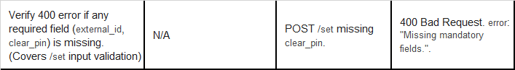
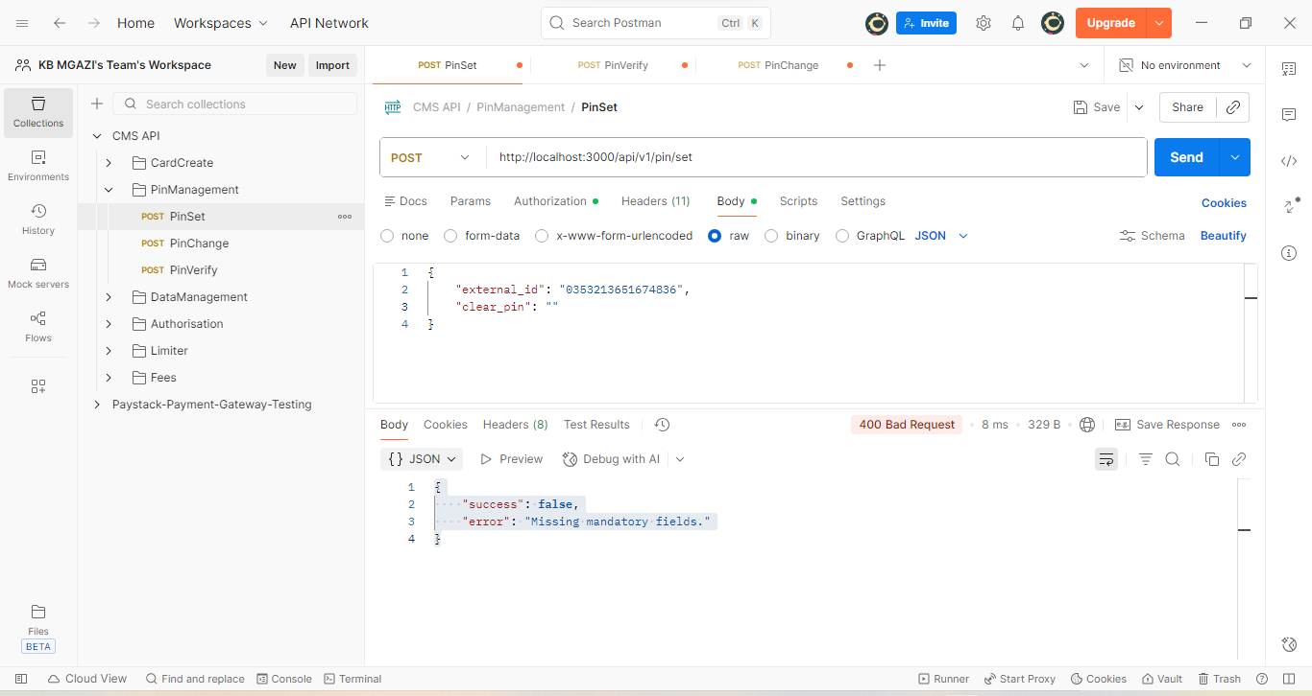
Request:
{
"external_id": "0353213651674836",
"clear_pin": ""
}
Response:
{
"success": false,
"error": "Missing mandatory fields."
}

